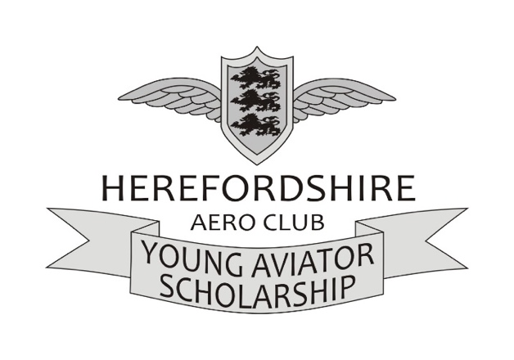
CLOSING DATE: Friday 10th May, 2024 at 10.00 a.m.

The aim of the scholarship is to assist the successful individual to gain the first part of their Private Pilots Licence. The scholarship covers only direct training costs for the first ten hours. The costs of obtaining the Class 2 Medical Certificate and any associated travel, subsistence and accommodation expenses are the responsibility of the scholarship winner.

For 2024 we are delighted to welcome Pooleys Flight Equipment as a supporter of our scholarships. They have kindly donated a student starter pack which includes a flight bag, log book, the initial flight training book and knee board.

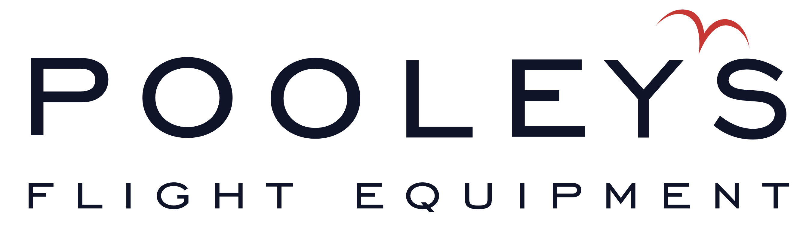

The criteria for the successful application includes:

- Your ability to undertake and complete the scholarship during August 2024
- You must be aged 17 - 24 on 1st April, 2024
- You are responsible for arranging travel to and from the airfield whilst training

Training will be carried out at Herefordshire Aero Club, Shobdon Airfield.

Applications will only be accepted if they are completed on this form. Please send your completed form as a single document to: headoftraining@shobdonairfield.co.uk

Use and Protection of Personal Data

The information that you provide in this form (when completed) is used solely and specifically for the selection and administrative purposes of the scholarship programme. The Company only uses personal data in accordance with the Data Protection Policy which confirms with current (UK) legislation. With your specific permission, your data will be shared with members of the Company for scholarship selection and administrative purposes and will not be released to a third party for other purposes without your prior permission. By signing this form, you acknowledge and give consent for the Company to share your details for the purposes stated.
SCHOLARSHIP APPLICATION FORM

The completed form should be scanned or saved as a single document and submitted by email.

FORENAME |  | SURNAME

Date of Birth ……………………………………. Age on 1st April, 2024 ……………………………………..

Address …………………………………………………………………………………………………………………………………………

Email ………………………………………………………………… Tel No. …………………………………………………………….

Secondary schools attended …………………………………………………………………………………………………………

Dates attended ……………………………………………………………………………………………………………………………...

Have you flown before …………………………… If so hours flown ……………………………………………….……..

Location ………………………………………………………………………………………………………………………………………..

Why do you want this scholarship?

Explain your career plans and what the impact of winning this award will have on those plans. Include details of how you plan to fund your flying progress beyond this scholarship?

Over the last 3 years, which single achievement of yours have you been most proud of and why?

Please tick to confirm you have read the following before signing:

I confirm I would be available to commence training in August 2024

I agree to abide by the decision of the interview panel and if selected to the terms and conditions of the scholarship

I hereby certify that all information included in this application is true and to the best of my knowledge

I hereby acknowledge and consent for Herefordshire Aero Club to share my details for the administrative purposes of the scholarship

I am not aware of any medical condition which would preclude the issue of a Class 2 medical certificate issued in the UK in accordance with Part-Med.

SIGNED: ………………………………………………………………………….. DATE: …………………………………………….

Signature of Parent/Guardian if applicant currently under 18 years of age

SIGNATURE …………………………………………………………………………………………………………………………………..

FULL NAME ………………………………………………………………………………………………………………………….………

RELATIONSHIP TO APPLICANT …………………………………………………………………………………………………….

DATE …………………………………………………………………………………………………………………………………………..

